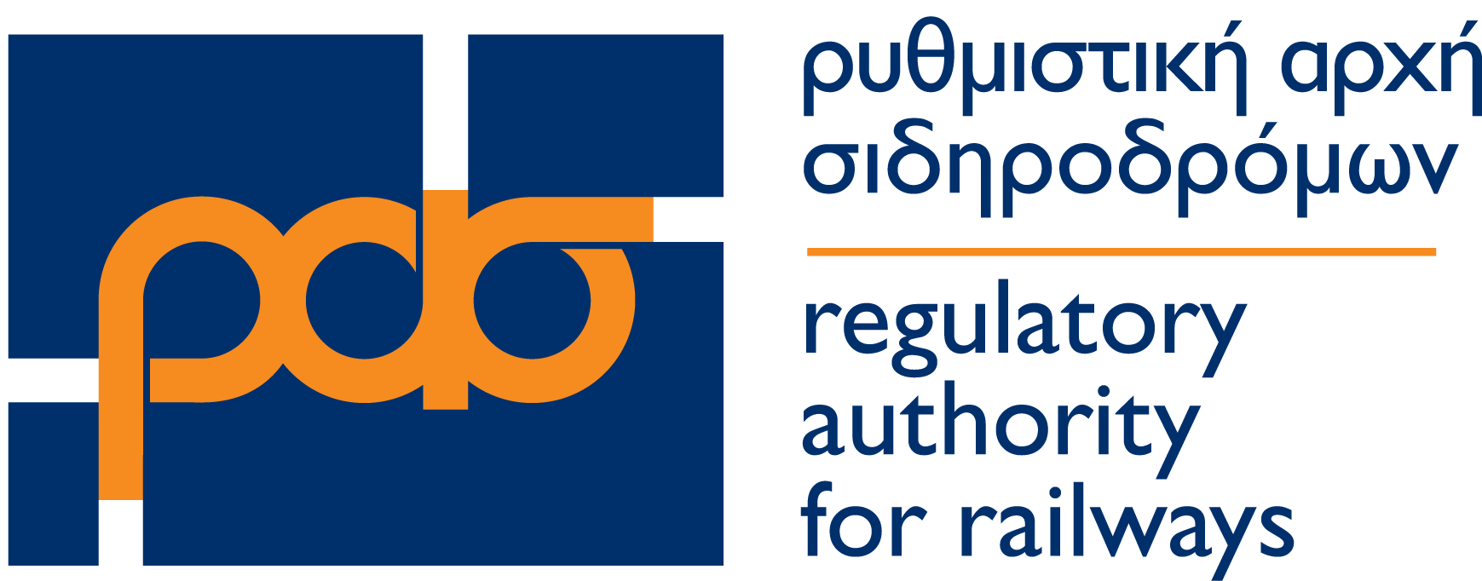
COMPLAINT FORM
(Under ar. 33 of Regulation (ΕU) 2021/782)
Name*
Surname*
Address
City – Postal code
Telephone*
Email*
Complaint against Railway Undertaking * | - HELLENIC TRAIN SA  - STASY SA
Complain against Station Manager | - OSE SA
Ticket number
Ticket price
Itinerary number
Station of Departure *
Station of Arrival*
Scheduled date and time of Departure * | …../…. /…… …… : ……
Scheduled date and time of Arrival* | …../…. /…… …… : ……
Actual time of Departure | …… : ……
Actual time of Arrival | …… : ……
Reasons for the complaint under Regulation (EU) 2021/782*:
- Transport contract (Article 4)
- Bicycles (Article 6)
- Travel information (Article 9)
- Availability of tickets and reservations (Article 11)
- Through-tickets (Article 12)
- Liability of railway undertakings for passengers and their luggage (chapter III)
- Reimbursement and re-routing (Article 18)
- Compensation (Article 19)
- Assistance (Article 20)
- Right to transport (Article 21)
- Information to persons with disabilities and persons with reduced mobility (Article 22)
- Assistance at railway stations and on board (Article 23)
- Complaints (Article 28)
- Information to passengers about their rights (Article 30)
- Other

Describe the problem:

Attachments (supporting documents)
- Reply from the Railway Undertaking

☐ I consent to the processing of personal data, within the framework of RAS's competences, in accordance with paragraphs 11-12 of article 28 of Law 3891/2010 (A'188) and EU Regulation 2021/782 on "Rail passengers’ rights and obligations.”

Fields marked with an asterisk (*) are mandatory.
How to submit a complaint:
- Online
- Fill the complaint form and send an email to info@ras-el.gr or by post, 33 Stadiou str. Athens, 10559

